Lab 2: Containerization & Kubernetes Orchestration
Task 4: Docker Network

1. Objective
Demonstrate communication between two Docker containers over a user-defined Docker network, first by resolving one container's name (Docker's embedded DNS) and then by addressing it directly via its container IP address.

2. Creating a Custom Network and Attaching Two Containers
A user-defined bridge network was created, then two containers were attached to it: the Task 1 Flask app (server) and a lightweight curl-enabled container (client) used purely to issue requests to the app from inside the network.
docker network create lab2-net
docker network inspect lab2-net --format "Name: {{.Name}} Driver: {{.Driver}}"

docker run -d --name lab2-net-app --network lab2-net lab2-python-app:1.0
docker run -d --name lab2-net-client --network lab2-net curlimages/curl:latest sleep 3600

docker ps --filter name=lab2-net
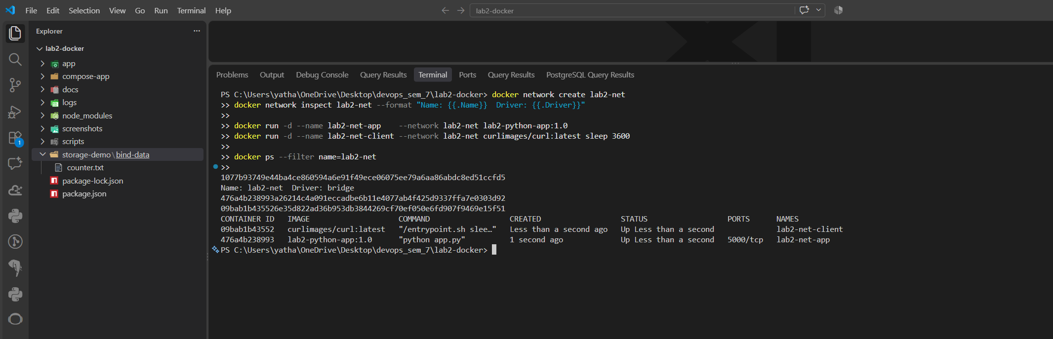

3. Communication by Container Name
User-defined bridge networks (unlike the legacy default bridge network) run an embedded DNS server that automatically resolves every attached container's name to its IP address. From inside lab2-net-client, the app was reached purely by name:
docker exec lab2-net-client curl -s http://lab2-net-app:5000/
docker exec lab2-net-client curl -s http://lab2-net-app:5000/health
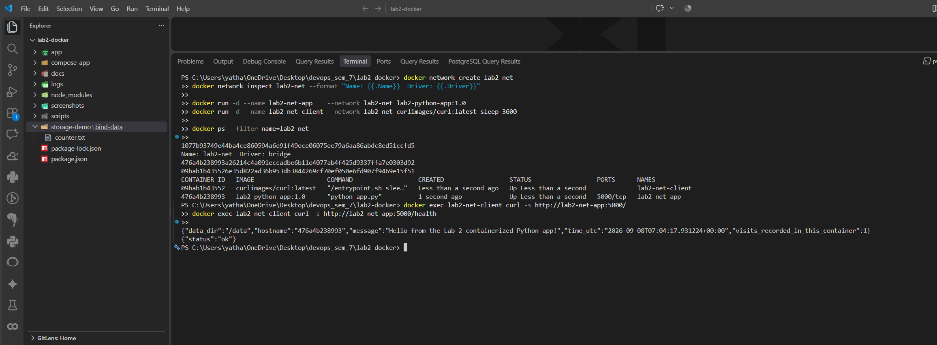

4. Communication by Container IP Address
The same app container's IP on lab2-net was then looked up and used directly, bypassing DNS resolution entirely:
docker inspect -f '{{(index .NetworkSettings.Networks "lab2-net").IPAddress}}' lab2-net-app

docker exec lab2-net-client curl -s http://172.20.0.2:5000/
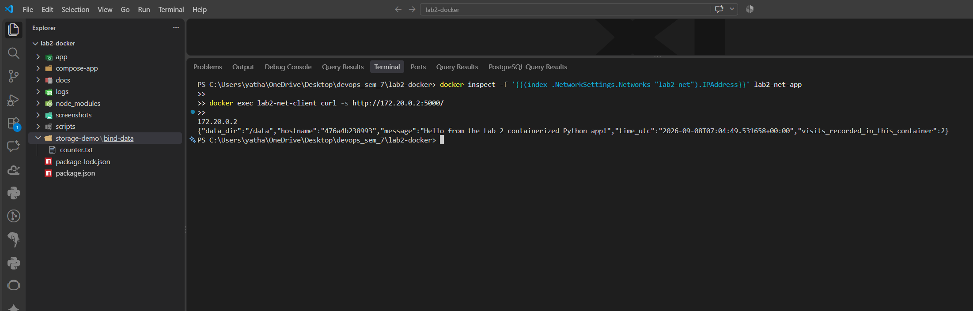
.

5. Network Membership Summary
docker network inspect lab2-net confirms both containers as connected endpoints with addresses inside the 172.20.0.0/16 subnet assigned to the network:
Container | Role | IP Address on lab2-net
lab2-net-app | Flask server (Task 1 image) | 172.20.0.2/16
lab2-net-client | curl client (curlimages/curl) | 172.20.0.3/16

6. Conclusion
Two containers were placed on a single custom Docker bridge network (lab2-net) and shown to communicate successfully over HTTP both by resolving the server container's name through Docker's embedded DNS and by addressing its container IP address directly, with docker network inspect confirming both containers as members of the same 172.20.0.0/16 network.

